**Name: Vishnu Mohan**

**Roll No: 51**

**Batch: MCA B**

**Date: 25-04-2022**

**NETWORKING & SYSTEM ADMINISTRATION LAB**

**Experiment No.: 6**

**Aim**

Familiarization of basic Linux commands.

**Procedure**

**1. sudo useradd**

This commands in Linux allows you to add a new user from an admin privileged terminal

**Syntax:-** $ sudo useradd username

**Output:-**





**2. sudo passwd**

This command in Linux allows to set a password for a newly added user

**Syntax:-** $ sudo passwd username

**Output:-**

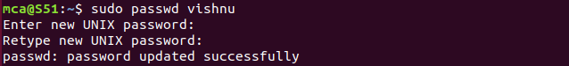

**3.** **sudo groupadd**

This command helps to create a new group

**Syntax:-** $ sudo groupadd –g id groupname

**Output:-**



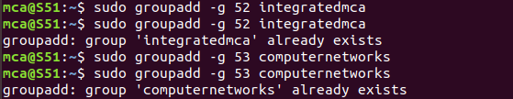

**4. sudo usermod**

This command is used to add a specific user to a group.

**Syntax:-** $ sudo usermod –G groupname username

**Output:-**



**5. id**

This command helps to see the information of a user such as which groups are those in which a specific user belongs to and so

**Syntax:-** $ id username

**Output:-**



**6. compgen -g**

This command is used to show all the users and groups reside in the system

**Syntax:-** $ compgen -g

**Output:-**

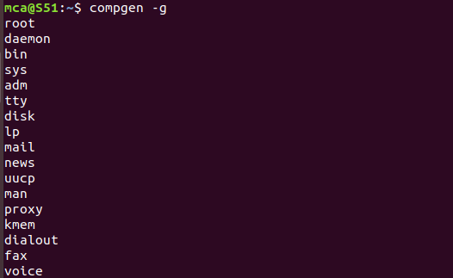

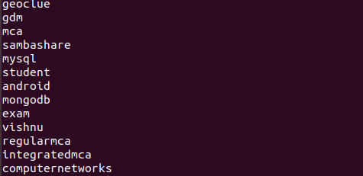

**7. compgen –g username**

This command shows only the user corresponds to the specified username

**Syntax:-** $ compgen –g username

**Output:-**



**8. sudo userdel**

This command helps to delete a specific user from the system

**Syntax:-** $ userdel username

**Output:-**



**9. sudo groupdel**

The command used to delete a group from the system

**Syntax:-** $ groupdel groupname

**Output:-**

C:\Users\Student\Desktop\exp7\9.png

**10. chmod**

This command is used to set/change directory permission of a file.

**Syntax:-** $ chmod permissions filename

**Output:-**

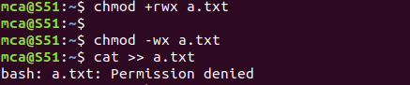

**11. sudo chown**

This command used to change the ownership of a file

**Syntax:-** $ sudo chown username filename

**Output:-**



**12. sudo ls -l**

This command used to list the files of a given directory

**Syntax:-** $ ls -l filename

**Output:-**



**13. sudo ssh**

This command used to access another computer on the same network.

**Syntax:-** $ sudo ssh username@ipaddress

**Output:-**

